**Portable Explosives and Narcotics Detector**

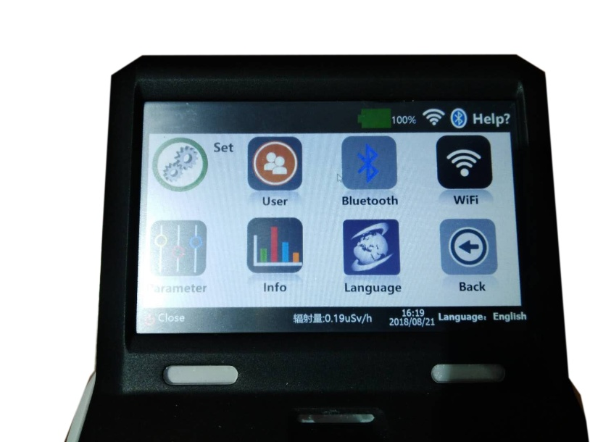

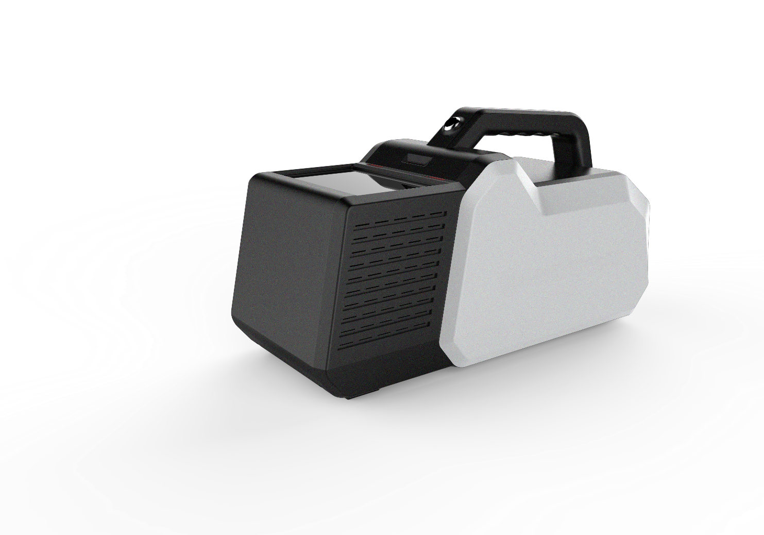

ADVANTAGE

***To check if there is any explosives and narcotics hidden on a person or in baggages***

* Portable
* Light Weight
* Wireless
* Rich data base
* Identifying common explosives, drugs and other substances, and also TATP and HMTD
* Can record new explosives and narcotics
* Can transmit data base to another BT-100
* Smart
  + 3 seconds analysis time
  + Easy to change explosive system to narcotics system
  + LAN×1 ，Bluetooth，Wifi，USB, VGA
  + Can print out the reports
  + Radiation monitoring

**INSTRUCTION**

**System**

**Can detect explosive and narcotis. Database can be copied to other BT-100. Analysis report can be printed out after contacting printer.**

**Technology**

Ion Mobility Spectrometry (IMS)



**Package**

**Packed by PVC box**

**48*40*25cm**

**0.048CBM**

**Sampleing**

**Using stick to sampling on a test paper**

**DETALS**

Portable Explosive and Narcotics Detector is used to detect the explosives and narcotics are hidden on a person or in the baggage

**DETALS**

Microseismic human presence detection system (MHPDS) is used to inspect and detect human presence hiding in any kind of vehicle and its containers. MHPDS can sense the vibrations caused by the human heartbeat and breath, to maximum ensure the effect of anti-e scape detection.

**Aplication:**Prisons，Border Security，Correctional and mental facilities, Homeland Security，Port Security，Entrance security at Critical infrastructures，etc.

**TECHNICAL SPECIFICATION**

|  |  |
| --- | --- |
| Technology | Ion Mobility Spectrometry (IMS) |
| Database | Explosives : TNT, RDX , PETN, NG, AN ,BP, RDX , Tetryl , HMX , DNTetc.  Drugs: METH, COC , MDMA , THC, Ketamine,MOP etc. Additional substances can be added |
| Sensitivity | Particle: 200pg level; |
| Analysis Time | 2~10 seconds(2~10s) |
| Warm-up Time | Less than 10mintes (hot-start: 3 minutes) |
| Alarm | Visual and audible alarms with the substance‘s name displayed on the LCD screen |
| Monitor | 5.0 inch color TFT LCD |
| Memory | Large memory up to 500G |
| Total weight | < 2.5kg |
| Interface | LAN×1 ，Bluetooth，Wifi，USB×2 (with support for keyboard,mouse,large storage etc.) VGA(support screen extending) |
| Power | 24V/10A/Dc（Adapter with 110~220V AC） |
| Battery | 12 hours or above |
| Dimensions  Operating conditions | 322x148x178mm (LxWxH)  Temperature -20°C~55°C; rel. Humidity <95% |

**APPLICATION:**

* **Government:** Court, Police office, Prision, etc;
* **Public place:** Station, Airport, Station, etc;
* **Others:** Hotel, Shopping mall, Entrance of building, etc;

