**Desktop liquid security detector**

**Description**

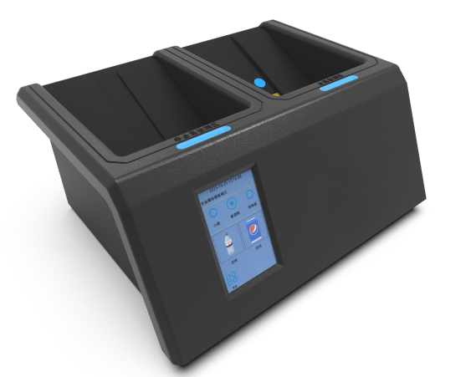

is the desktop liquid safety detector which using dielectric constant technology to meet the requirements of the material and thickness of non-metal and metal container liquid for detecting, special security check equipment for liquid security inspection. Without opening the container, this machine can distinguish plastic, glass, ceramics, metal, and flexible packaging container of liquid such as rapid detection, and safety liquid such as water, coke, milk, fruit juice. Used in the subway, railway, big events, important place such as liquid security checks. The product has got the testing report from the ministry of public security alarm system products quality supervision, and this product has been used in several important places and urban rail transit institution.

**Technical Specification**

|  |  |
| --- | --- |
| Detect purpose | Flammable liquid in the sealed containers |
| Containers materials | Plastic/glass/metal/ceramic/paper (no aluminum foil coating) |
| Detect volume | Plastic/glass containers 100-5000ml, Metal containers, 100-2000ml |
| Liquids can be detected container | 60mm height 400mm or less, or less30 mm in diameter 200 mm or less or less |
| Boot time | 3.5 seconds |
| Self checking time | 2 seconds |
| Detection speed | Plastic/glass container for 1-2 seconds, Metal containers for 2-5 seconds |
| The minimum detectable amount | 100ml |
| Large storage | Not less than 100000 records |
| Power | 50W |
| Size | 520mm (L)*370mm(W)*200mm(H) |
| Weight | Approximately 8 kg |
| Package | 630mm(L)*520mm(W)*370mm(H);GW:11kg |
| Optional detection mode | Small bottle, regular bottle and special containers |
| Data transfer | USB, Internet access, WIFI, RS232 |
| Relative humidity | 0-99% RH (condensate) |
| Liquid temperature | 0 to 40°C |
| Warning alarm | Sound,Light,LCD screen |
| Environment temperature | - 10° C - 55 ° C |

**Application**

Industrial and mining enterprises, Banks, private mansion, airports, customs, prisons, exhibition hall, casinos, large-scale activities, the judicial organs, the examination room, etc.